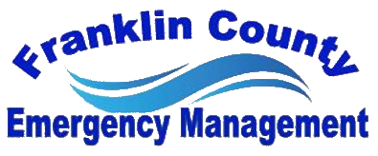

Franklin County Build a Disaster Bucket Event Improvement and Strength Questionnaire

NAME:
AGENCY:

PRIMARY STRENGTHS
1.
2.
3.

PRIMARY AREAS OF IMPROVEMENT
1.
2.
3.

COMMENTS:

