FIRE ADVISORY

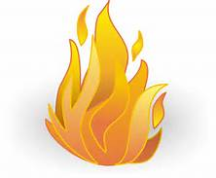
Attention Franklin County Residents due to very dry conditions in our area. All residents need to be precautious when burning trash, debris, and other items. There is NO burn ban issued at this time.
BE FIRE SMART!
Fire Precautions
- Check Conditions (Do not burn when conditions are dry and/or windy)
- Look Up choose safe burning site away from overhanging limbs, buildings, vehicles, and equipment. You’ll need at least three times the height of the pile of vertical clearance.
- The site should be surrounded by gravel or mineral soil (dirt) at least 10 feet in all directions. Keep the surroundings watered down during the burn and have a shovel close by.
- Keep your piles small and manageable. Add additional debris as the fire burns down.
- If using a burn barrel, make sure it’s made entirely of metal, properly equipped (at least three evenly-spaced, three-inch, screened vents and metal top screen) and in good condition.
- Always stay with your fire until it is completely out! Drown the fire with water, turn over the ashes with a shovel and drown it again. Repeat several times.

